  - Classification of Human-LLM-generated emails based on Machine learning models
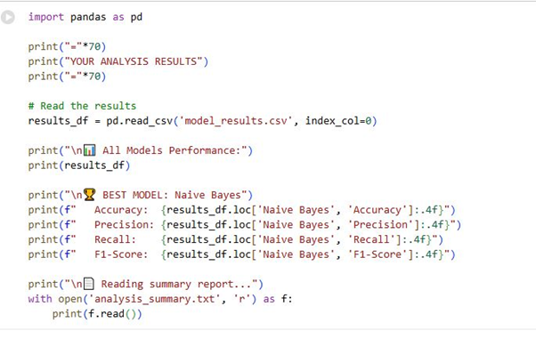

Fig 1 Machine learning models

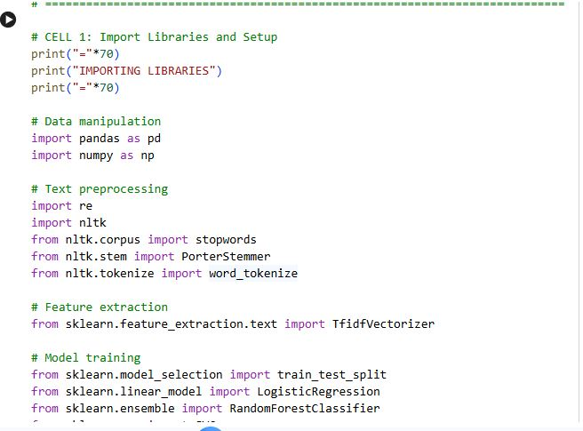

Fig 2 Screenshot of Import libraries and setup

Explanation: This explains essential libraries for data processing, visualisation and machine learning. And downloading Natural Language Processing for preprocessing tasks.

Dataset loading and combination
Explanation: In this section, four CSV files containing human-generated and LLM-generated data were combined into a single dataset with suitable labels (0 for human-generated, 1 for LLM-generated).
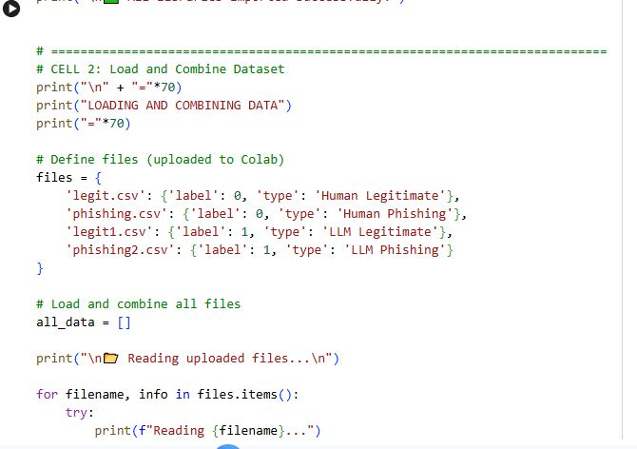
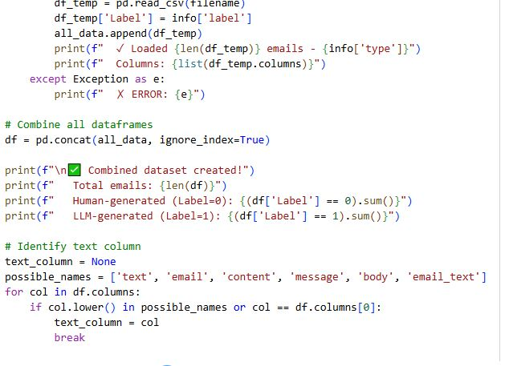
Fig. 3 Screenshot of Loading and Combining Datasets

Explanation: In this section, four CSV files containing human-generated and LLM-generated data were combined into a single dataset with suitable labels (0 for human-generated, 1 for LLM-generated).

Data Exploration

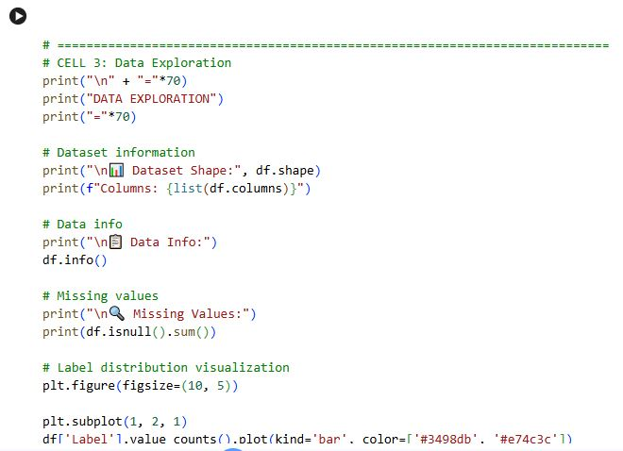
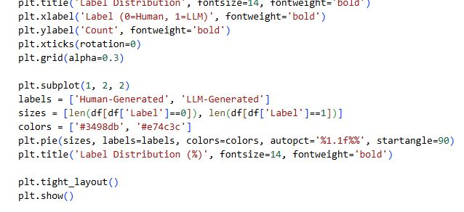
Fig 4 Screenshot of Data Exploration

Explanation: This section involves exploratory data analysis (EDA) to comprehend the structure of the dataset, detect the column containing email text, check for missing values, and visualise the distribution of labels.

Data preprocessing
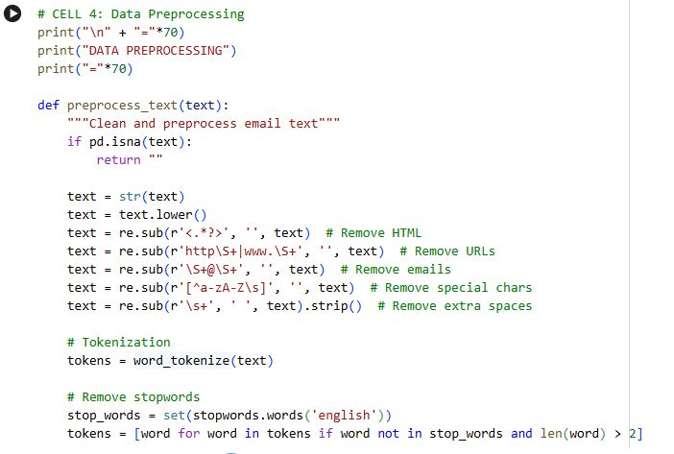

Fig. 5 Screenshot of Data Preprocessing

Explanation: This section explores a comprehensive preprocessing performance by cleaning the email text by eradicating noise of URLS, HTML, and special characters, tokenising the text, eradicating common words (stop words), and reducing words (stemming).

Feature Extraction

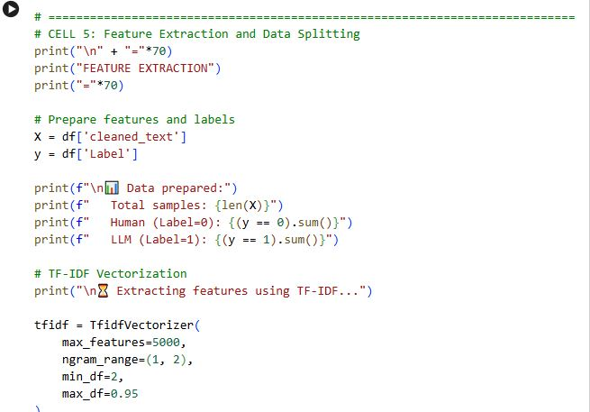

Fig. 6 Screenshot of Feature Extraction

Explanation: In this section, TF-IDF (Term Frequency-Inverse Document Frequency) converts text into a numerical vector. There are 5000 vector features, where each feature represents the essence of a word in that email relative to the whole dataset.

Model Training
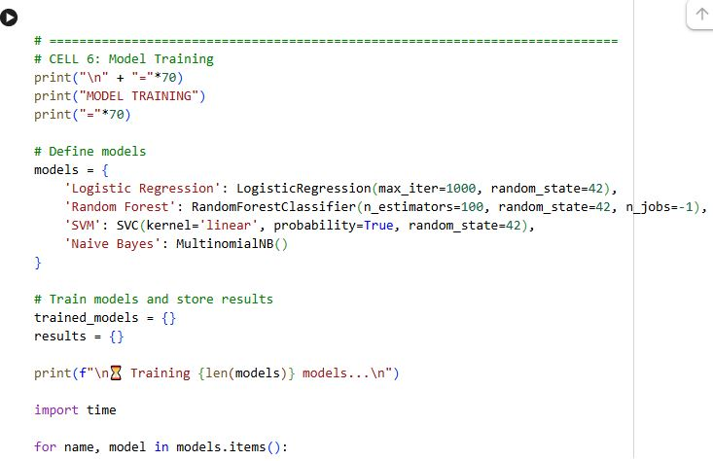
Fig 7 Screenshot of Model Training

Explanation: In this section, four separate machine learning algorithms were trained on the same training data:

Model Evaluation

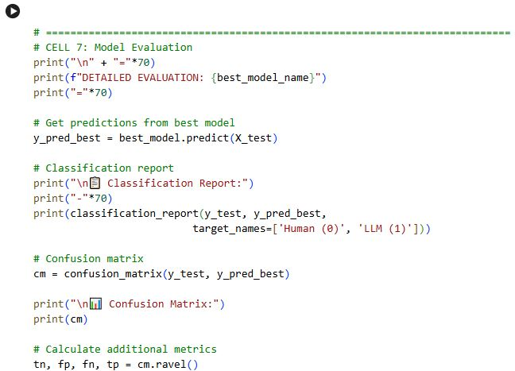

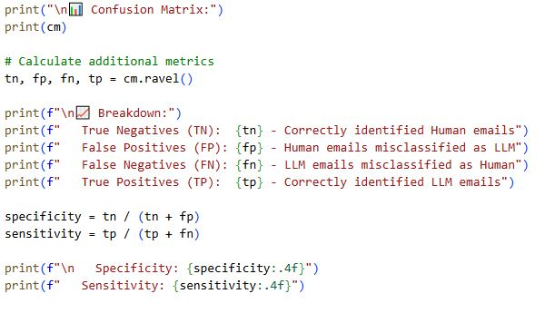

Fig 8 Screenshot of Evaluation

Explanation: In this section, the best-executing model performs a thorough evaluation. A report classification indicates recall, precision, and F1-score for each class. A confusion matrix explores the dispersion of authentic and unreal predictions, enabling insights into the types of errors the model makes.

Visualizations

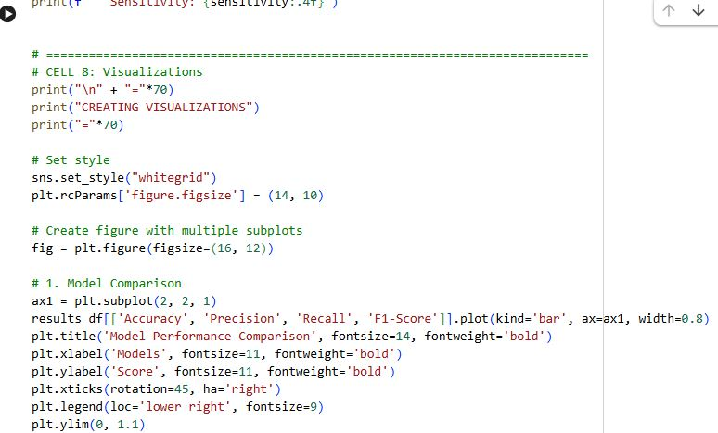

Fig 9 Screenshot of Visualisations
Explanations: This section presents results based on the Confusion matrix, chart, and other relevant information.

